**Program**

**Monday, January 17, 2022**

**Musical** Paul White

**Interlude** “National Anthem”

**Welcome** Jillian Harvey, Director of Diversity, Equity & Inclusion Division, Health & Human Services; MLK Committee Member

**Invocation** Pastor Ross Goodman, St. Paul Evangelical Lutheran Church

**Musical** Paul White

**Interlude** “Lift Every Voice and Sing”

**Poem** Steven Ratiner, Arlington Poet Laureate, accompanied by Paul White and Dr. Debora Jackson)

“We Dreamers”

**Master of** Jillian Harvey, MLK Committee Member

**Ceremonies**

**Free Will Offering** Crystal Haynes, Journalist, MLK Committee Member

**Musical** Paul White and the CFB Ensemble (Caribbean Foundation Performance of Boston) recorded 2021, “Battle of Jericho”

**Introduction** Mikel Satcher, MLK Committee Member

**to Keynote**

**Keynote** Dr. Lynn Perry Wooten, President of Simmons

**Presentation** University

**Master of** Jillian Harvey, MLK Committee Member

**Ceremonies**

**Benediction** Rev. Erica Richmond, First Parish Unitarian Universalist

**Closing Remarks** Ian Jackson, Chair of MLK Committee

**Closing Music** Mildred Walker and Paul White

“We Shall Overcome”, from January 2020 MLK Observance

**Performances**

Paul White

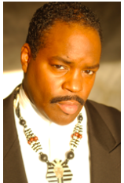Director of Music Ministry

Peoples Baptist Church of Boston

Paul White has performed throughout the United States and internationally as a recitalist, with his jazz trio Paul White & Company, and with a host of gifted artists including the Rev. James Cleveland, Bill Gaither, Billy Preston, and Nina Simone. He has opened for major artists including the renowned a cappella group Take Six.

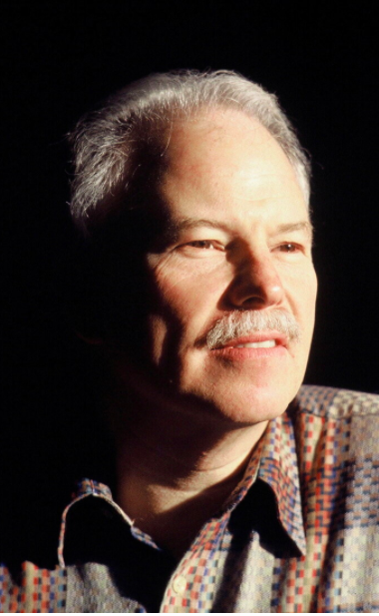Steven Ratiner

Current Poet Laureate

Arlington, Massachusetts

Steven is the author of three poetry chapbooks and has published work in numerous journals in America and abroad, including Parnassus, Agni, Blackbird, Hanging Loose, Poet Lore, Salamander, QRLS (Singapore) and Poetry Australia. Giving Their Word, a collection of poetry interviews, was re-issued in a paperback edition from University of Massachusetts Press and includes conversations with some of poetry’s most vital contemporary voices, such as Seamus Heaney, Charles Simic, Rita Dove, Bei Dao, and the last full-length interview with Bill Stafford before he died.

**Keynote: Dr. Lynn Perry Wooten,**

**President of Simmons University**

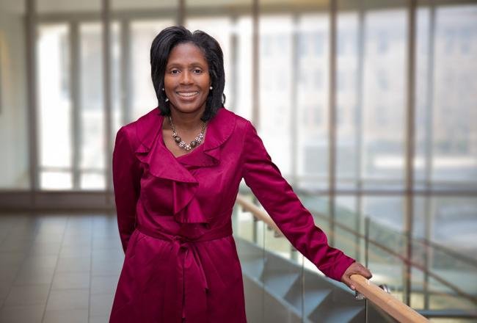

On July, 1, 2020 Dr. Wooten became the 9th president of Simmons University and the first African American to lead the university.

Specializing in crisis leadership, diversity and inclusion, and positive leadership—organizational behavior that reveals and nurtures the highest level of human potential—Dr. Wooten is an innovative leader and prolific author and presenter whose research has informed her work in the classroom and as an administrator. She first joined a university faculty in 1994 and has served in administrative roles since 2008. Dr. Wooten came to Simmons from Cornell University, where she was the David J. Nolan Dean and Professor of Management and Organizations at the Dyson School of Applied Economics and Management.

With leadership at the core of her work, Dr. Wooten’s research has ranged from an NIH-funded investigation of how leadership can positively alleviate health disparities to leading in a crisis and managing workforce diversity. She is the author of two books, Positive Organizing in a Global Society: Understanding and Engaging Differences for Capacity Building and Inclusion (2016) and Leading Under Pressure: From Surviving to Thriving Before, During, and After a Crisis (2010). Sharing her work at nearly 60 symposia and conferences, she also is the author of nearly 30 journal articles and more than 15 book chapters, as well as managerial monographs and numerous teaching cases.

Dr. Wooten grew up in Philadelphia, where she attended an all-girls high school. She earned a BS in accounting in 1988 from North Carolina Agricultural and Technical State University, a Historically Black College, where she graduated as valedictorian; an MBA from the Duke University Fuqua School of Business in 1990; and a PhD in business administration from the University of Michigan Ross School of Business in 1995. She received a Certificate in Advanced Educational Leadership from the Harvard University Graduate School of Education in 2018.

She is a past recipient of the University of Michigan Ross School of Business’s BBA Student Award for Teaching Excellence as well as the school’s Andy Andrews Distinguished Service Award. She also was chosen as a “Next Generation Business Thinker” by the Financial Times.

Find out more [here](https://www.simmons.edu/about/university-leadership/president/about-president).

***Thank you for joining in tonight’s celebration of Dr. King’s life and legacy.***

***May we move forward as one, with a fierce determination to advance truth, decency and equality.***

If you are interested in joining the committee contact dei@town.arlington.ma.us

DR. MARTIN LUTHER KING, JR.

BIRTHDAY OBSERVANCE COMMITTEE

Arlington, Massachusetts

Along with organizing a community celebration of Dr. King’s life and works in January of each year, the committee is charged with fostering racial understanding, tolerance, and respect for others, promoting non-violent means to settle differences of opinions, and recognizing people in the community who further the goals of Dr. King.